# Assignment Git

## 1. Creation of the git user accounts

* To config username: git config --global user.name <name>
* To config user email: git config --global user.email <email>
* To check the user accounts: git config --list

## 2. Difference between global, system and local

* global: global level configuration, (user details saved in ~/.gitconfig)
* Sytem: system level configuration, (user details saved in ./etc/gitconfig)
* Local: repo level configuration, (user details saved in .git/config file)

git config –help

For example, for global level configuration, if you would like to see user details:

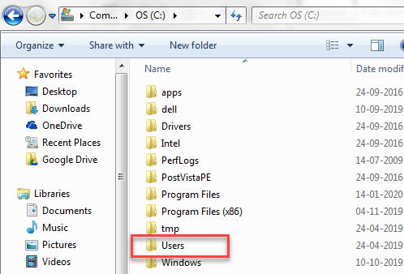

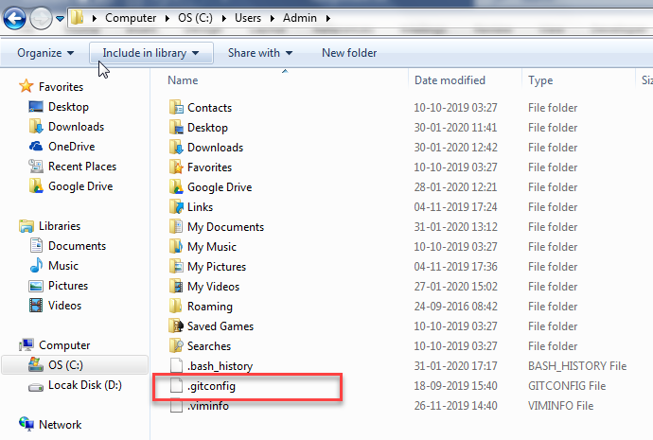

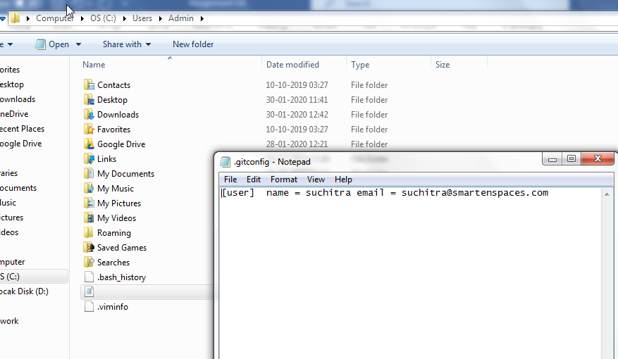

For local,

Type ls -la

-ls is list

-la is to see the hidden files

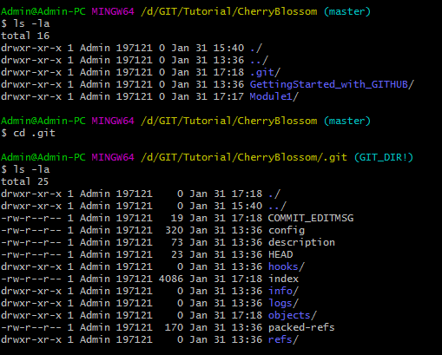

The user details is present in the confiq files.

To read the content of confiq, enter cat confiq

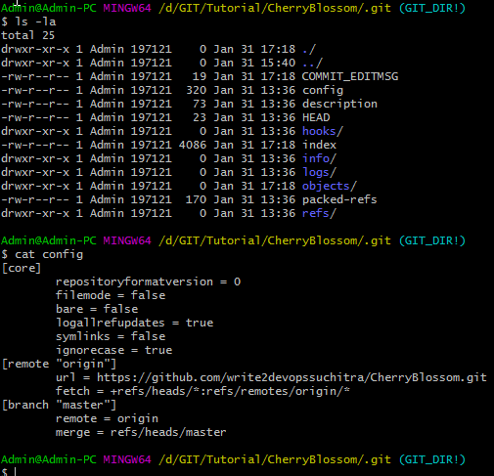

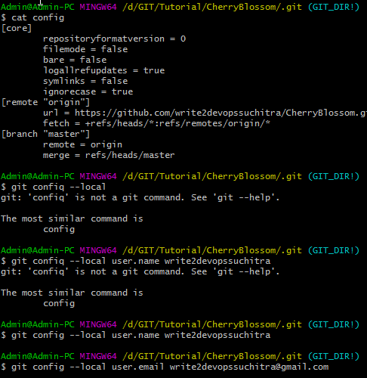

In system,

Check the c:/Program Files/Git/

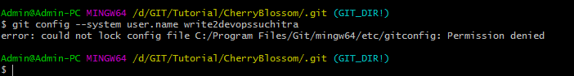

Permission to be given to the user.

Follow the pathe in the error message to provide permission. Select users and administrator to provide full control.

C:\Program Files

Right click Git folder

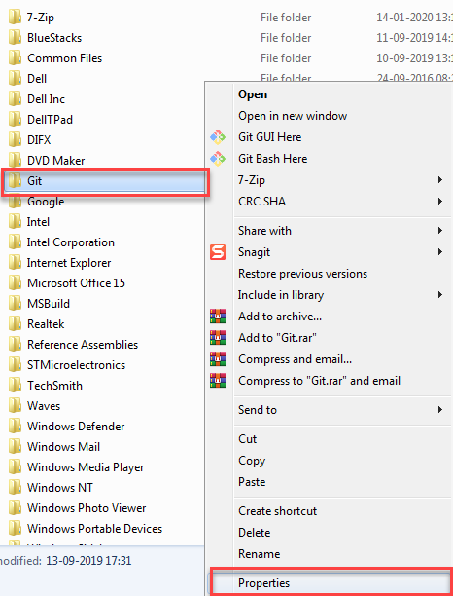

Security>Edit

User : Select, edit and provide full control

Administrator: Select, edit and provide full control

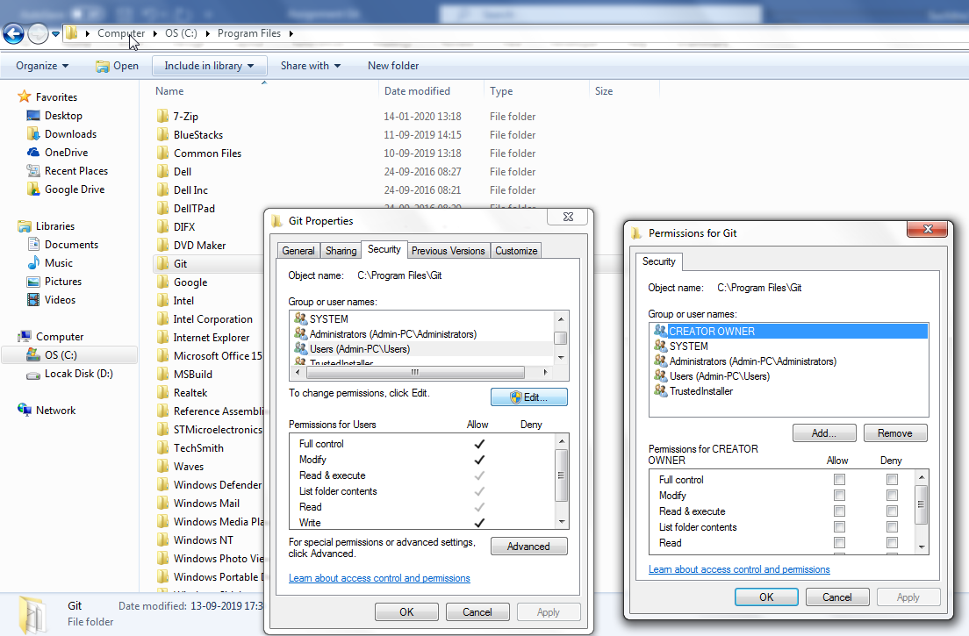

Enter

* git config - - local user.name write2devopssuchitra
* git config - - local user.email write2devopssuchitra@gmail.com

Now navigate to C:\Program Files\Git\mingw64\etc

Open gitconfig file



## 3. How to remove user accounts?

* git config --global --unset user.name <name>
* git config --global --unset user.email <name>

## 4. What are the phases available in git?

* workspace, staging(index), local repo
  + - git hub (central repo)

## 5. Data flow b/w these three phases

Work Space- > Staging ->Local Repository

git Status………….git add…………git commit -m

.Git push origin master is used to push code to central repository

## 6. Diff b/w new file and modified

* New file:
* Modified file:

## 7. How to check the modified content

## 8. How to check commit history?

* git log

## 9. How to check the commits committed by a user?

* git log --author <username>

## 10. How to check the committed files from a date (start date)

* git log --oneline --since=<date>

## 11. How to check the committed files till date (last date)

* git log --oneline --until=<date>

## 12. What is branch? How to create them?

## 13. What is git branch strategy?*

## 14. If you get merge conflicts, how to resolve them?

## 15. How to merge two branches?

## 16. How to abort merging?

## 17. What is the stash memory?

## 18. How can u save the files in stash memory

## 19. How to get the files back from the stash memory

## 20 Stash memory creation and deletion flow

## 21 What is tag? how to create them?

## 22 How to setup the origin?

## 23 How to check the list of branches in local (git) and remote(git hub)

## 24 Commands to work with the branch’s b/w local and remote repositories

## 25 What is diff b/w push and pull

* push: to send the updated files to the central repo
* pull: to get the updated files from central repo

## 26. Diff b/w clone and pull?

* Clone: to get the entire repository to my local machine
* Pull: to get updated files. Fetch and merge

Answer by tomorrow.......

-----------------------------------------------------------------------------------------

## 26. How to give the collaborating access permissions in git hub to the developers*

## 27. How to provide the SSH key authentication*

## 28. How to provide the branch protection policy in the git hub?

## 29. What are the main options available in git hub?

## 30. What is the diff b/w git, git lab and git hub?

## 31. What is versioning concept?

32. How to take backup and restore of git?